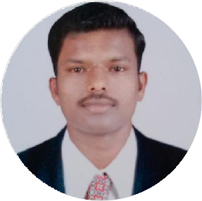

Ranjit Chavan

Clinical Support Solution

I am highly interested to get a chance in research oriented organizations, Where I can used my knowledge and skill to contribute in the progress of the industry as well as myself, and I will used my full curiosity in the industrial work.



At Chahutre Post Dhulpimpri Tal Parola Dist Jalgoan, Maharashtra 425111, India



06 December, 1999



[linkedin.com/in/ranjit-chavan- bb893122b](https://www.linkedin.com/in/ranjit-chavan-bb893122b)

# SKILLS

Strong Team Work and Communication

Working knowledge of MS Excel and MS Oﬃce

Time Management Skill

**EDUCATION**

## Bachelor of Pharmacy (84.45%)

### KBC NMU University Jalgoan

*07/2019 - 08/2022*, *Chopda, Jalgoan*

## Diploma in Pharmacy (75.60%)

### MSBTE Mumbai

*06/2017 - 06/2019*, *Sakri (Dhule)*

# WORK EXPERIENCE

## Clinical Data Associate (DMDA)

### IKS HEALTHCARE

*09/2022 - Present*, *Mindspace, Airoli (Navi Mumbai) India*

*Achievements/Tasks*

Understand clinical and non-clinical documents received from the clinic Understand the document type for ﬁling the document

Understand the naming convention for indexing the document

Abstract relevant clinical data like impression from diagnostic or lab reports in patient’s electronic account

For rejected documents understand physician’s feedback and correct accordingly Send back the data to the clinic that needs action from front oﬃce

Working on electronic health record (EHR) application

Data Analysis

# CERTIFICATES

Observation Skill

Diploma in Software Application (06/2015)

# LANGUAGES

1) English 2) Hindi 3) Marathi

*Full Professional Proﬁciency*

# PERSONAL PROJECTS

A study on formulation of marketing strategiesto promote a healthcare service.

# INTERESTS

Quality Assurance

Production

**ACHIEVEMENTS**

Certiﬁcation in Review On Pharmacovingilance Of Herbal Drug (02/2020) Certiﬁcation in National Symposium On Herbal Medicine (02/2020)

Quality Control